**DAILY ONLINE ACTIVITIES SUMMARY**

|  |  |  |  |  |  |  |  |
| --- | --- | --- | --- | --- | --- | --- | --- |
| **Date:** | | **7/6/2020** | | | | | |
| **Name of the Faculty** | | **REENA LOBO** | | | | | |
| **No. of Students Allotted for monitoring** | | | | | **19** | | |
| **Progress** | | | | | **GOOD** | | |
| **Whether collected report from all the allotted students** | | | | | **18,not submitted-ramitha** | | |
| **Online Test Summary** | | | | | | | |
| **Subject** |  | | | | | | |
| **Semester** |  | | | **Duration** | |  | |
| **No. of students Taken** | | |  | **Passing %** | |  | |
| **Certification Course Summary** | | | | | | | |
| **Course** | | **1.participated in quiz c programimg, data structrues, dbms and mysql and oops** | | | | | |
| **Certificate Provider** | |  | | | **Duration** | |  |
| **Coding Challenges** | | | | | | | |
| **Problem statement.** **write a java Program to print smallest and biggest possible palindrome word in a given string In this program, we need to find the smallest and biggest palindromic word present in the given string.**  **string:Wow you own kayak**  **Language used for solving: JAVA**  **Whether posted in Github: YES**  **Link:** <https://github.com/orgs/alvas-education-foundation/teams/3rd-year/discussions/63>  **How many students attempted :29** | | | | | | | |
| **Status: COMPLETED** | | | | | | | |
| **Uploaded the report in Github** | | | | | **yes** | | |
| **If yes Repository name** | | | | | <https://github.com/reenalobo/ONLINE-ACTIVITY-REPORT/upload/master> | | |
| **Uploaded the report in slack** | | | | | **yes** | | |

Certification Course Details: (Attach the snapshot and briefly write the report for the same)

**.participated in quiz c programimg, data structrues, dbms and mysql and oops**

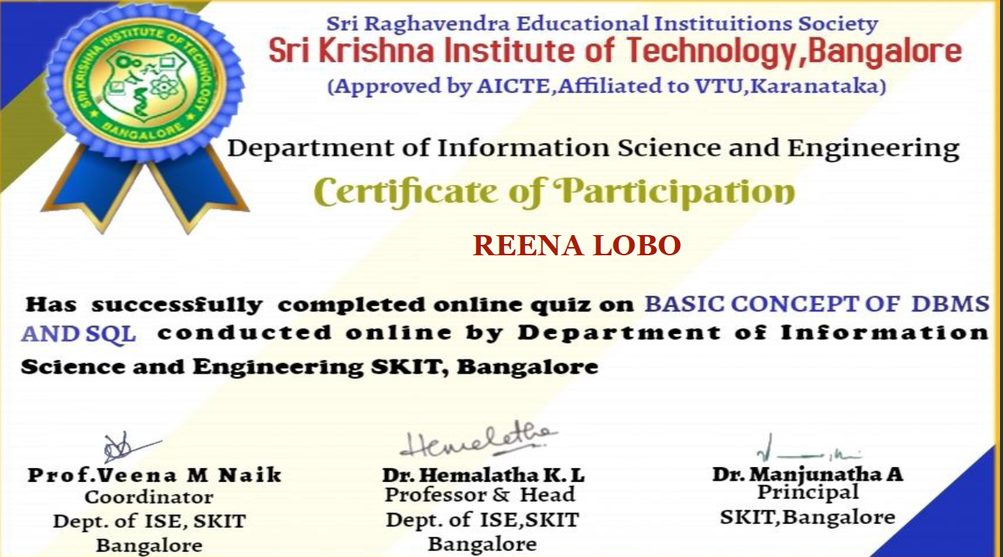

**Coding challenge:**

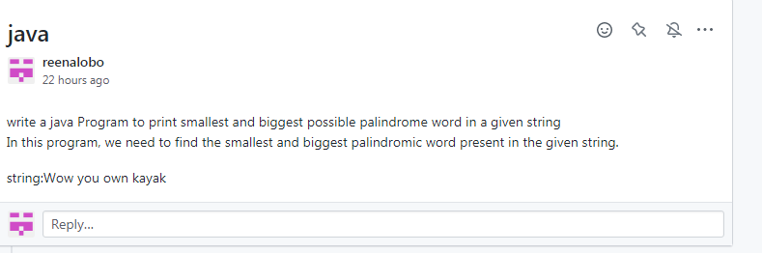

Students report:

Ravali:

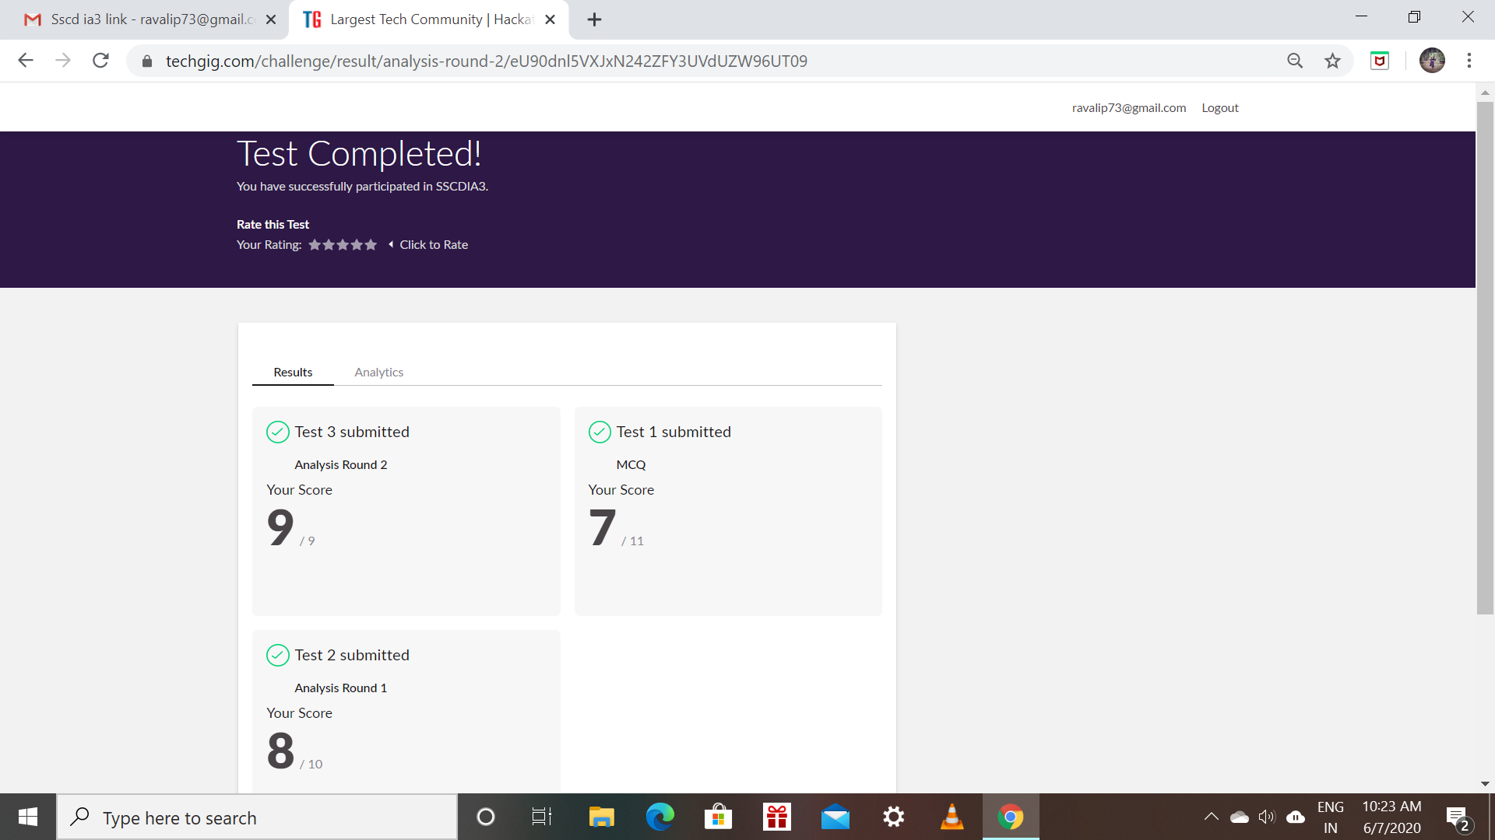

Certification Course Details: (Attach the snapshot and briefly write the report for the same)

* Todays topic is about learning the basic html tags and how to apply them to create a website.
* The lecture also contains about the css and the various body styles we need to include in our code.
* How to create a simple background with including buttons to navigate.

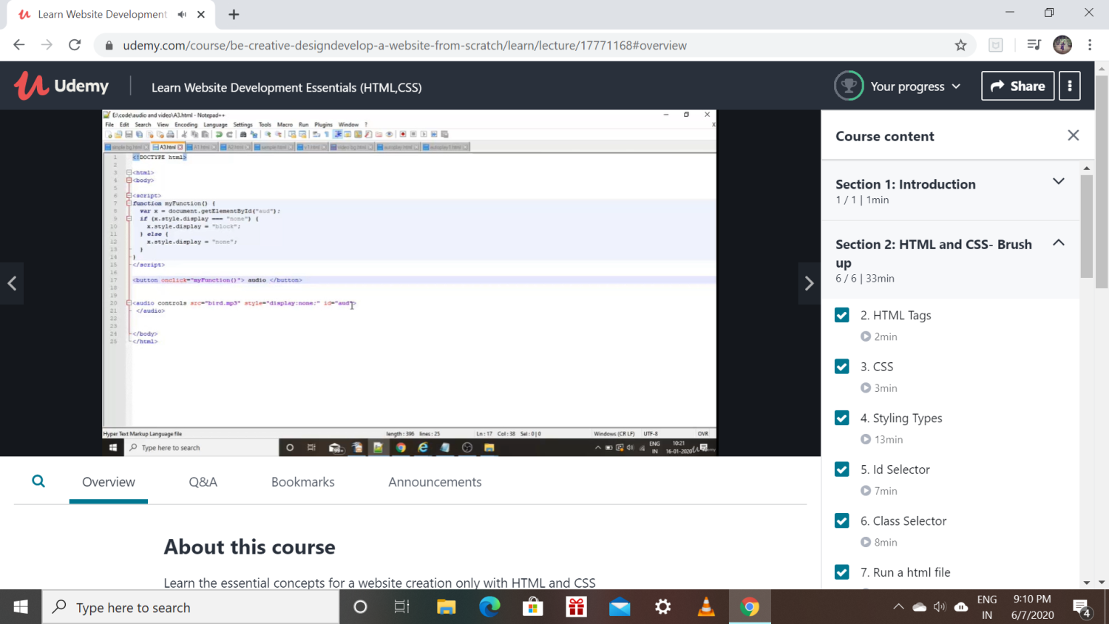

Raksha:

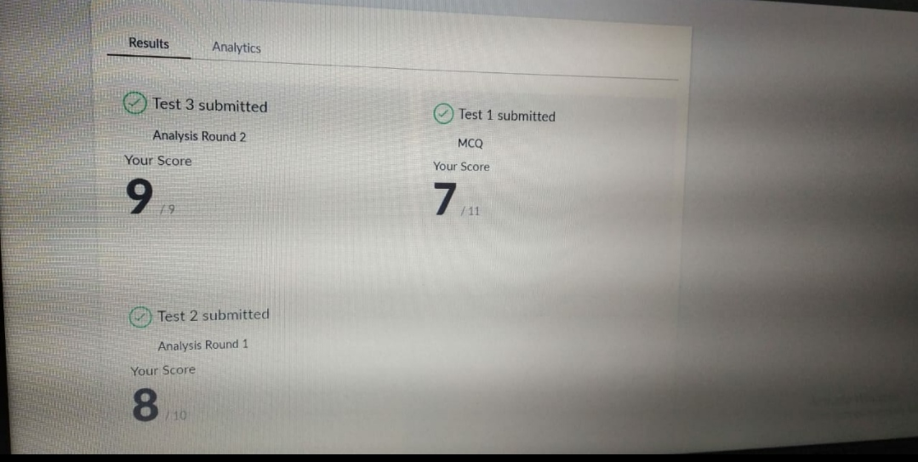

Scored 24 out of 30 in SSCD Test

Certification Course Details:

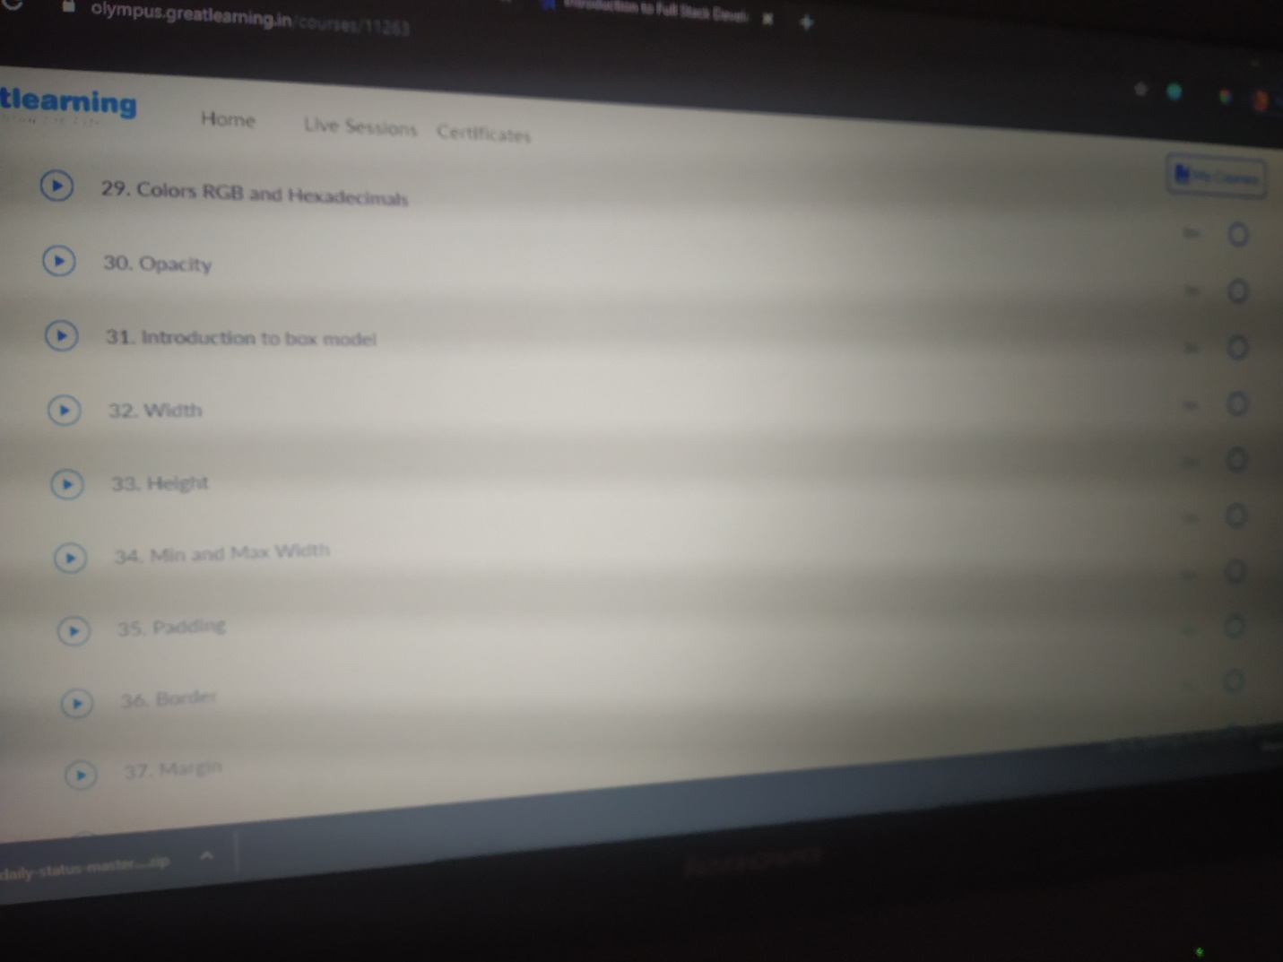

Rohan mahaveer:

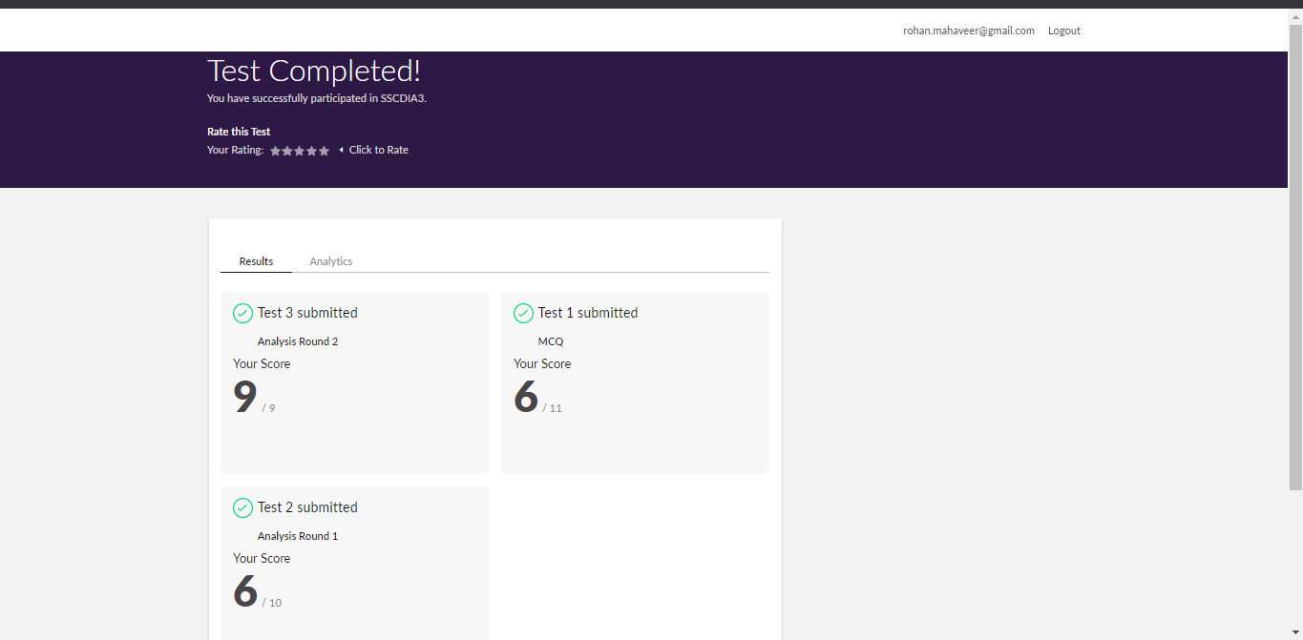

Scored 21 out of 30 in SSCD Test

Certification Course Details:

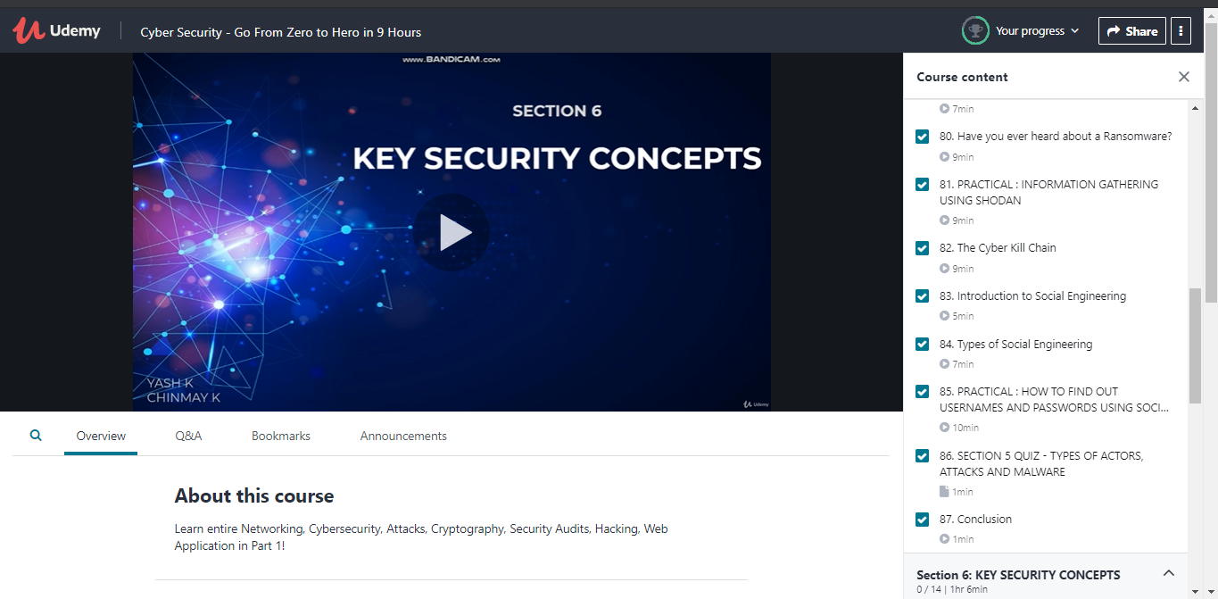

Preethi:

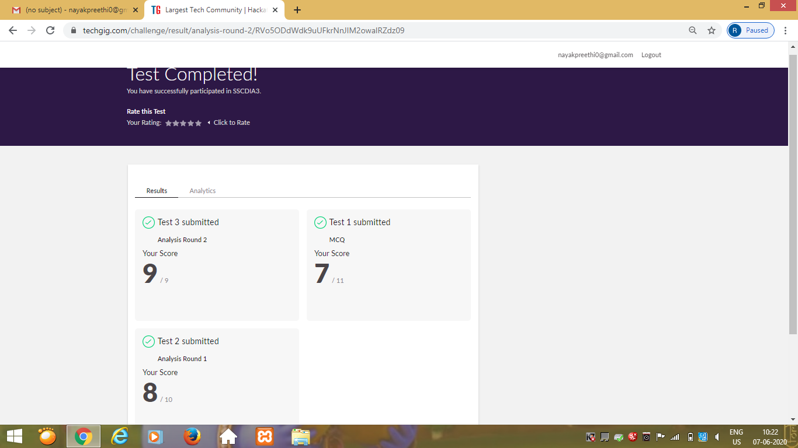

Certification Course Details: (Attach the snapshot and briefly write the report for the same)

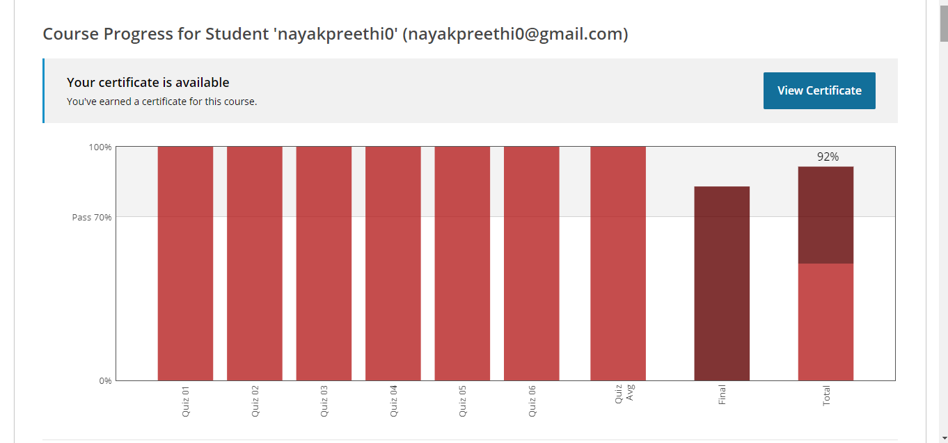

Pranav:

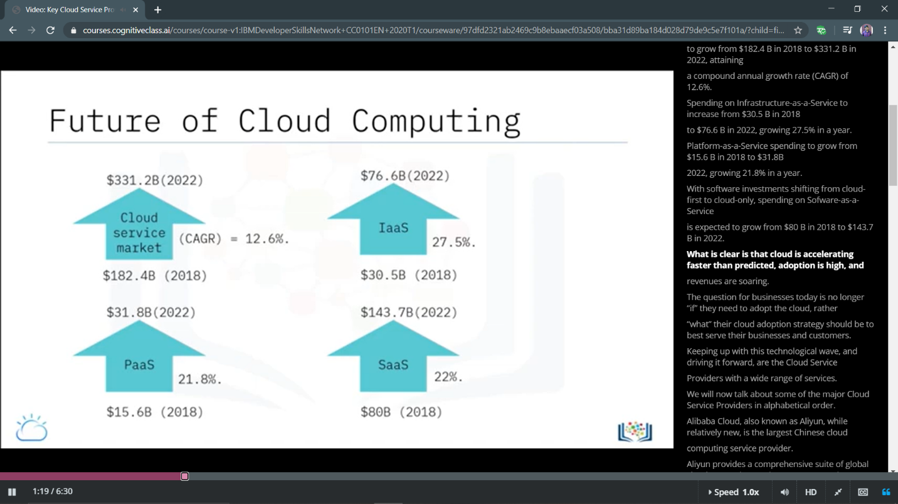

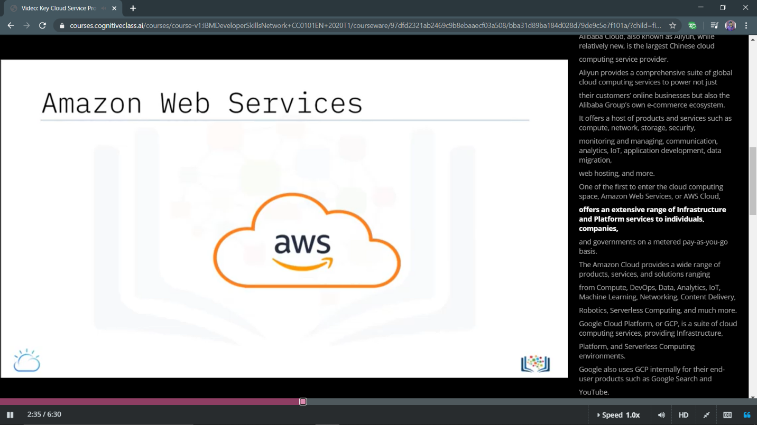

Rani:

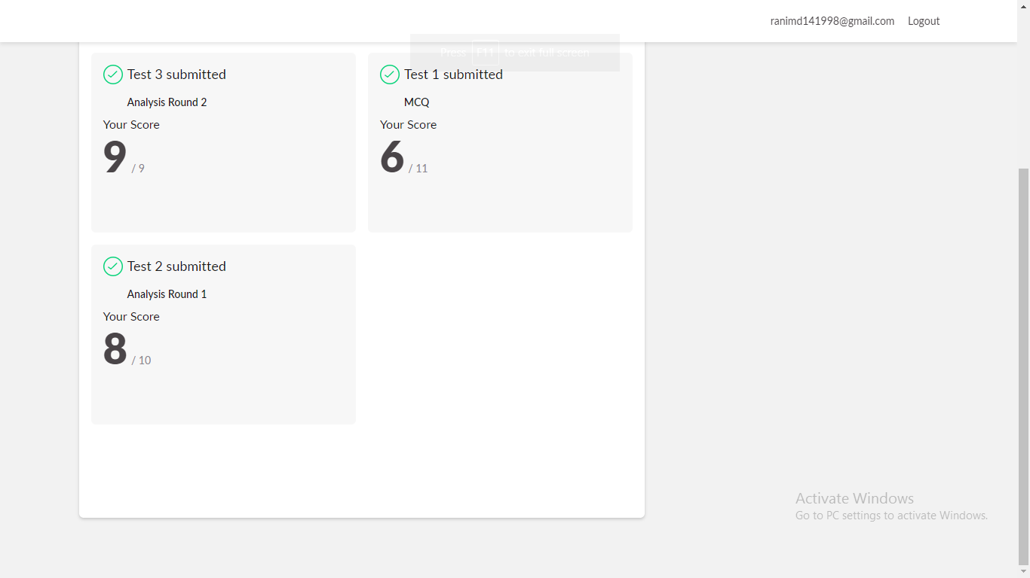

**Online Certification Details**

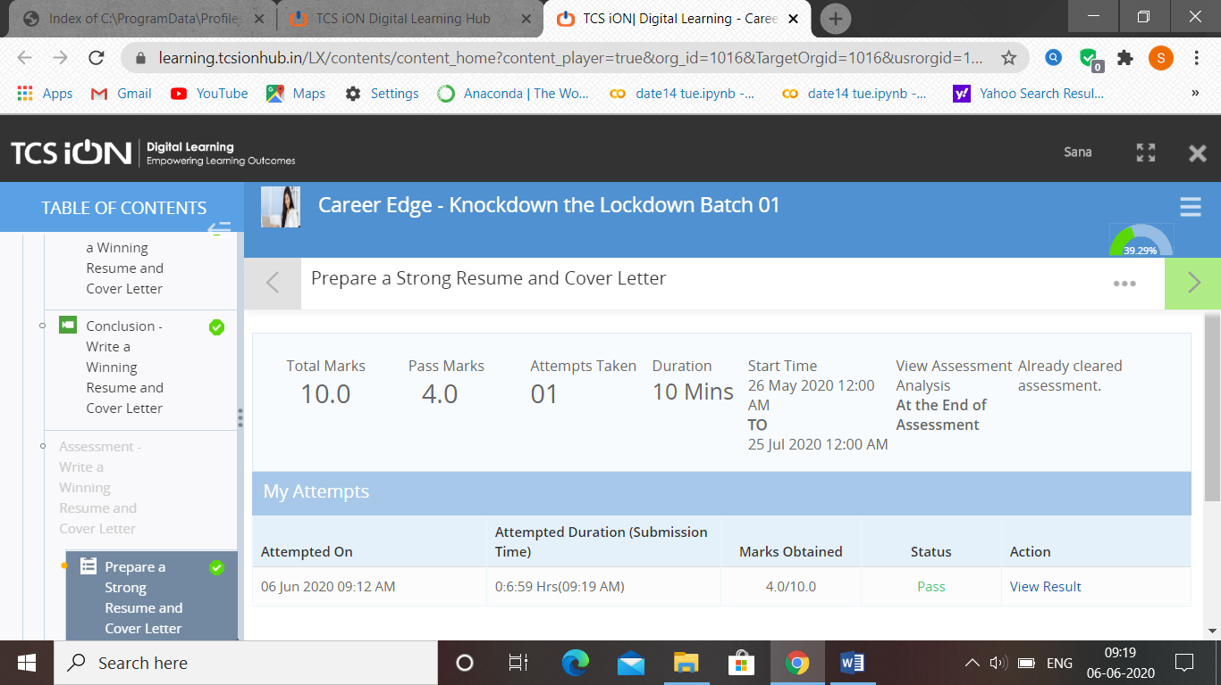

Rachana:

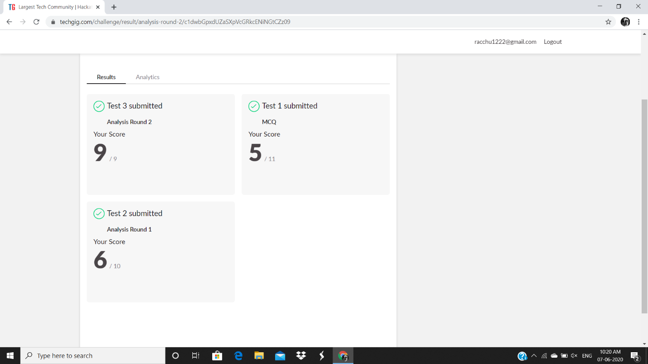

**Certification Course Details:**

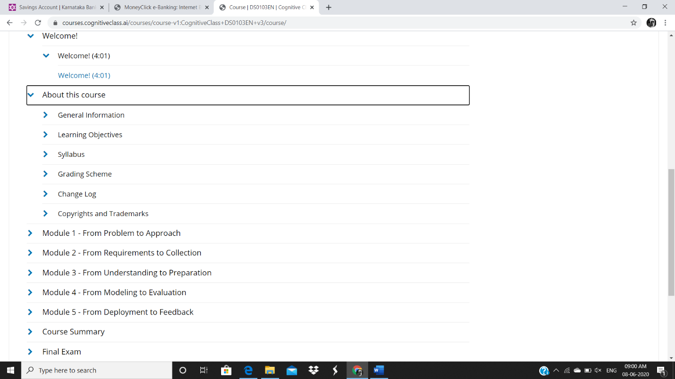

Priyanka”:

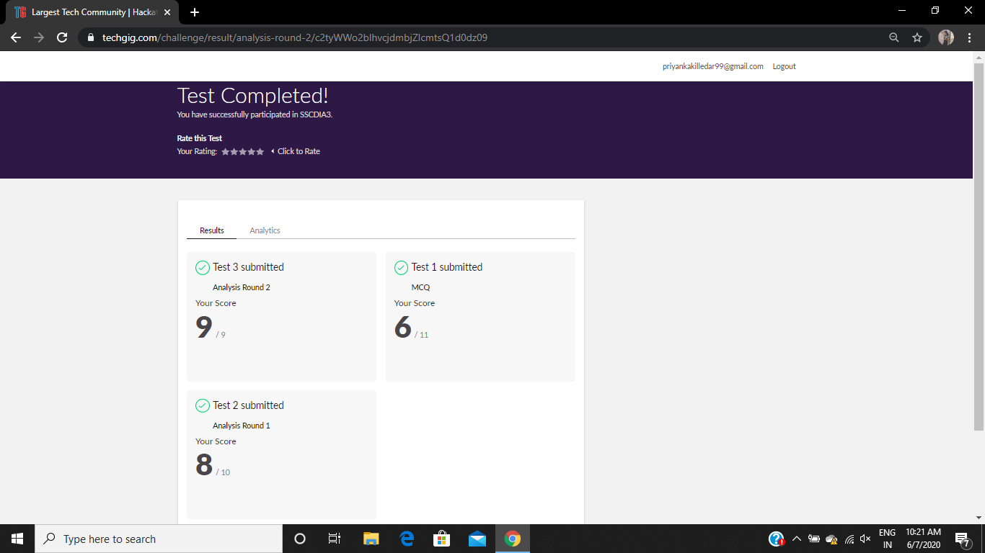

**Certification Course Details:**

**E-Box Classes:**

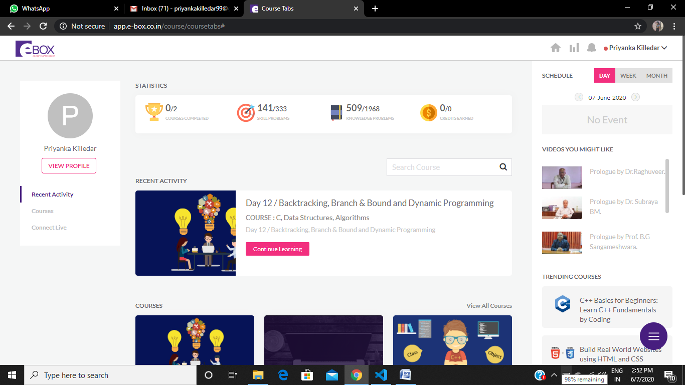

Sana:

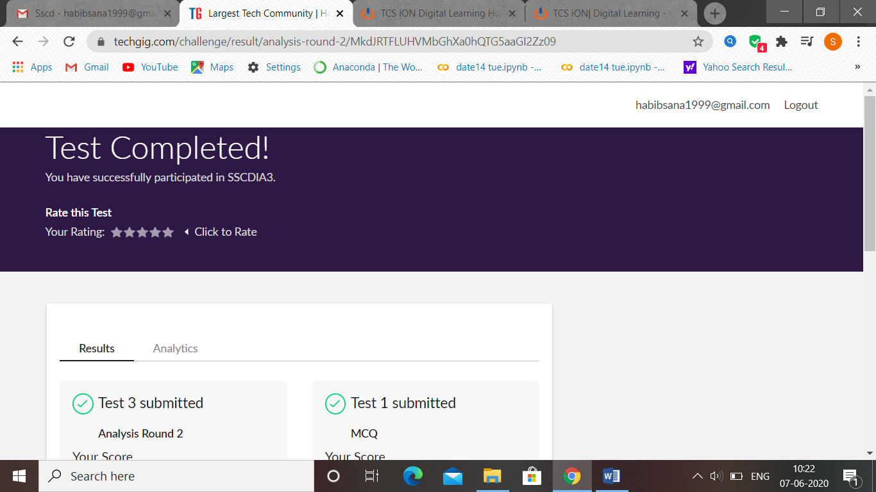

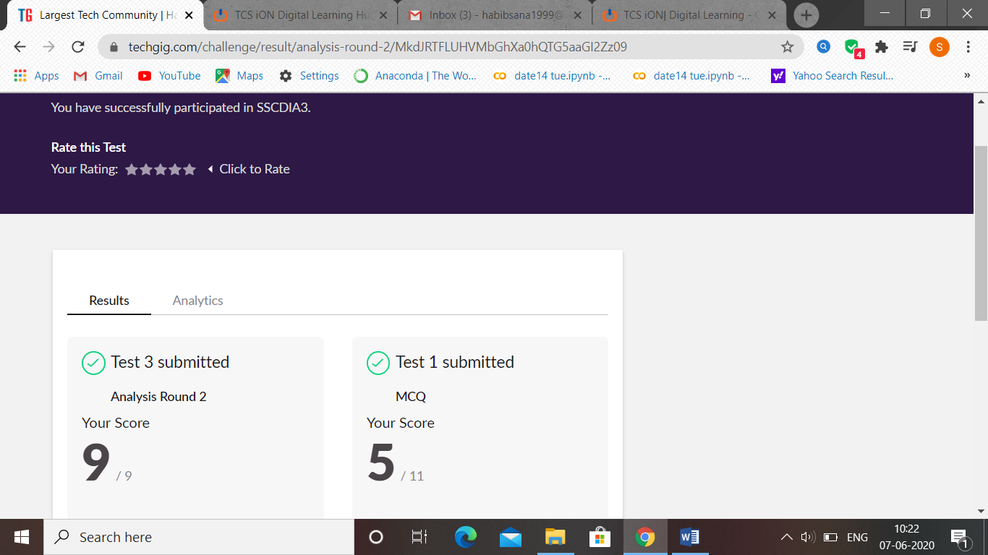

Atish:

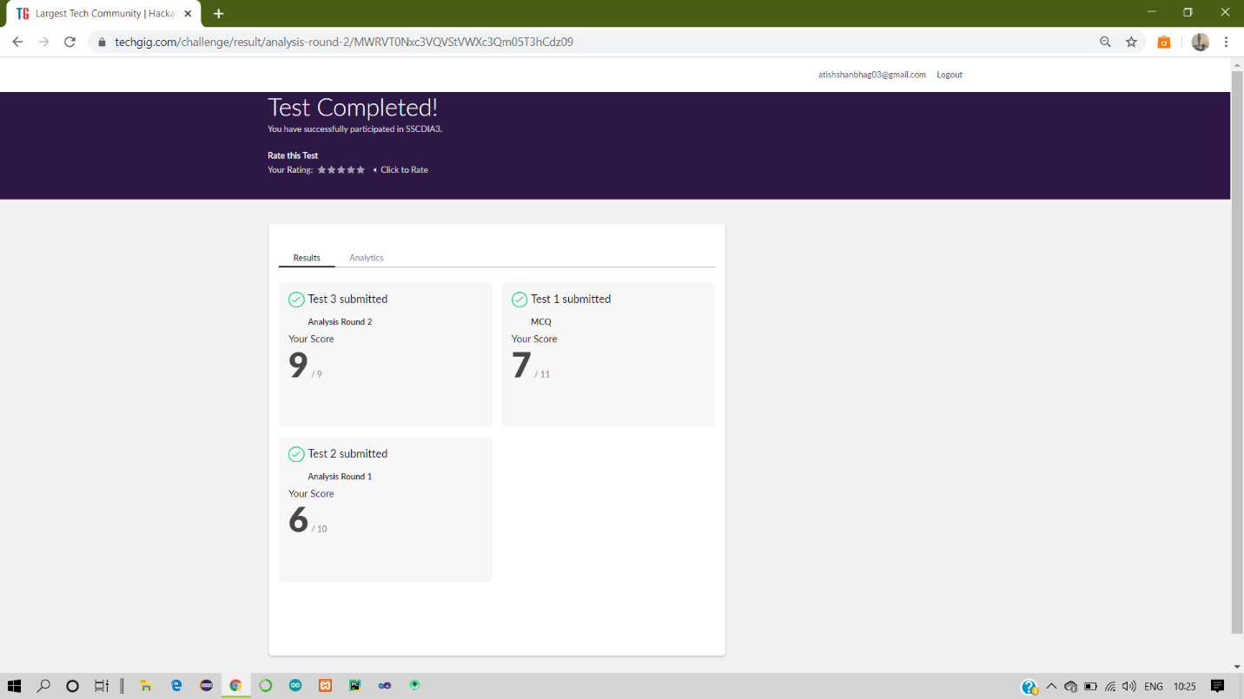

Certification Course Details:

Report

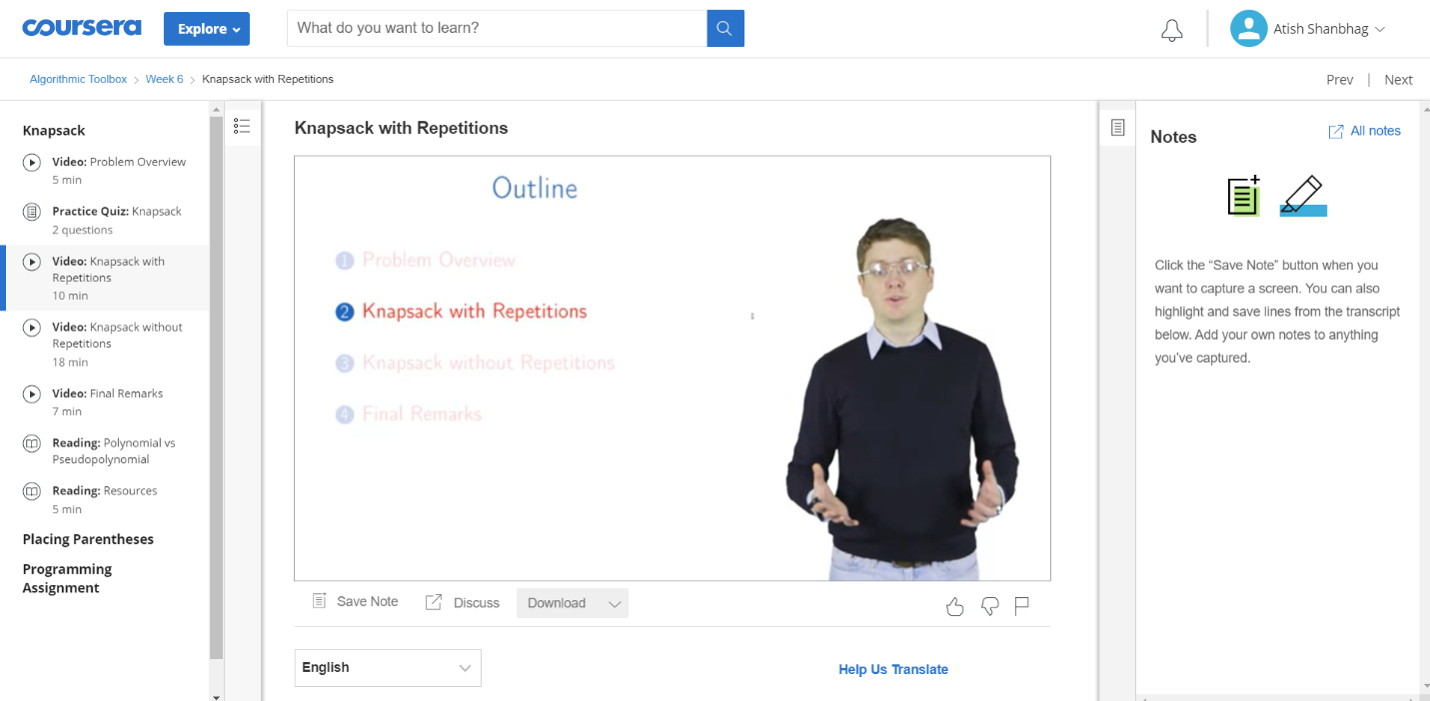

Dhruvil:

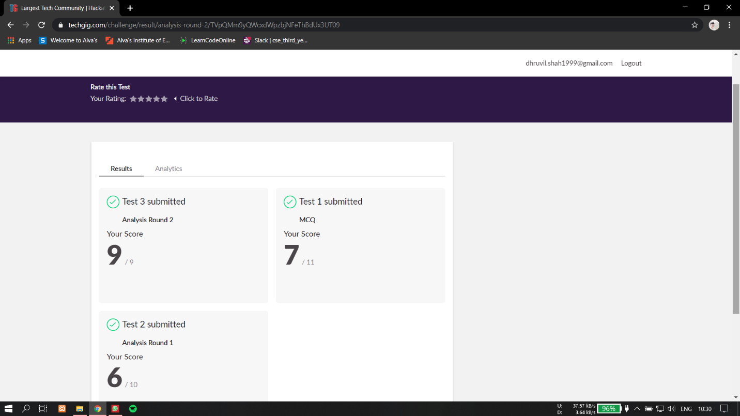

Certification Course Details:

Report

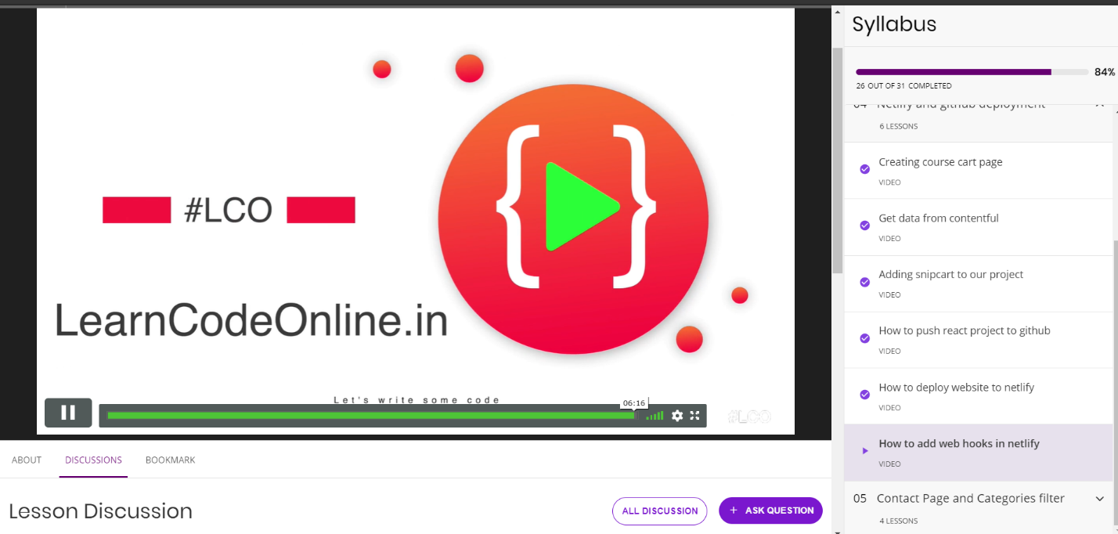

Priya h t:

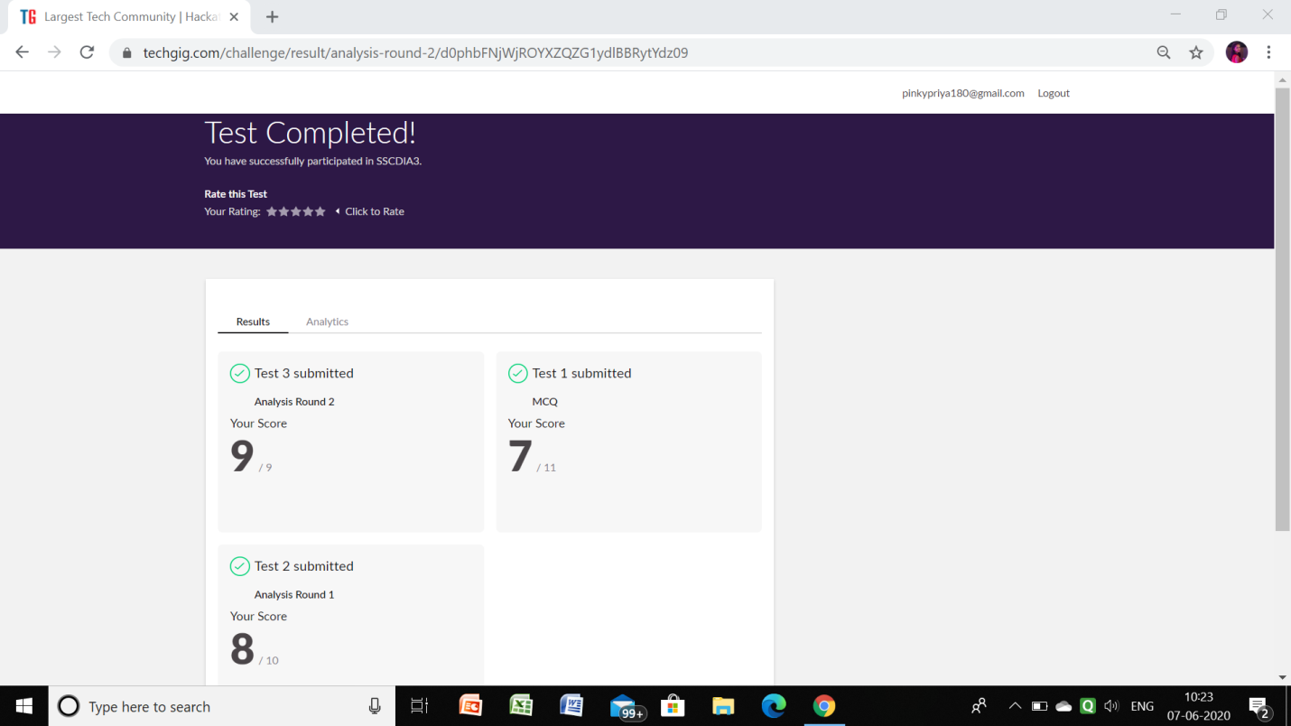

**Certification Course Details:**

Github link for information: <https://github.com/priya3028/Daily-status>

**Topics completed today:**

**Progress report:**

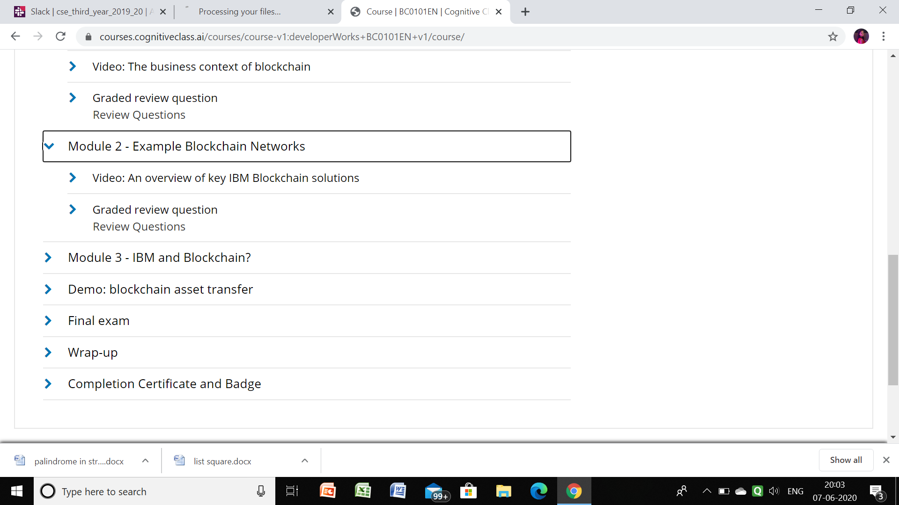

Ragahavi:

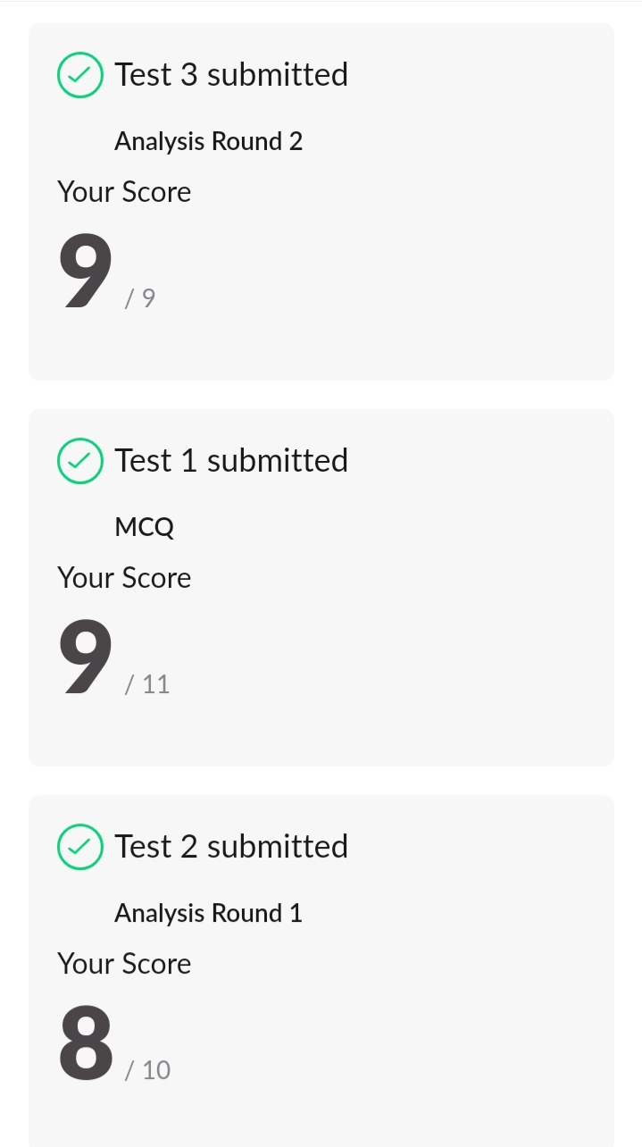

Sachin:

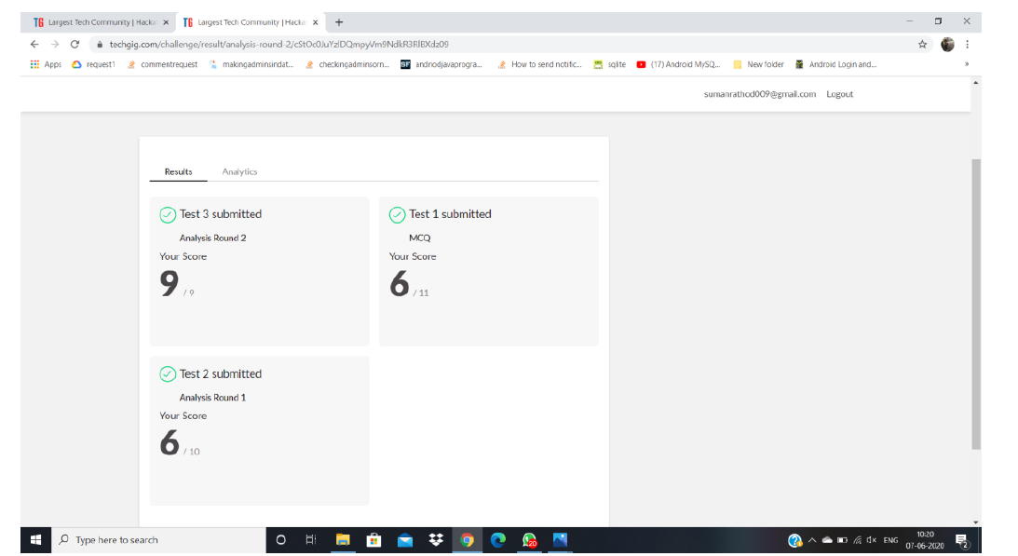

Rousha:

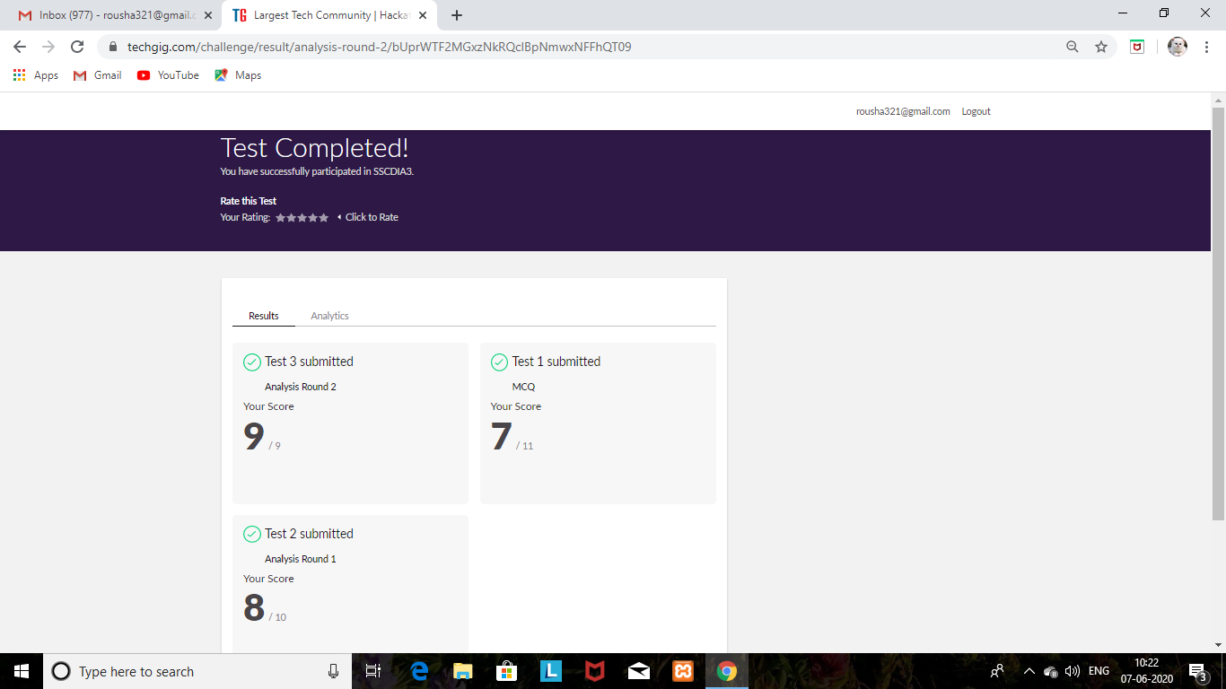

Certification Course Details: (Attach the snapshot and briefly write the report for the same)

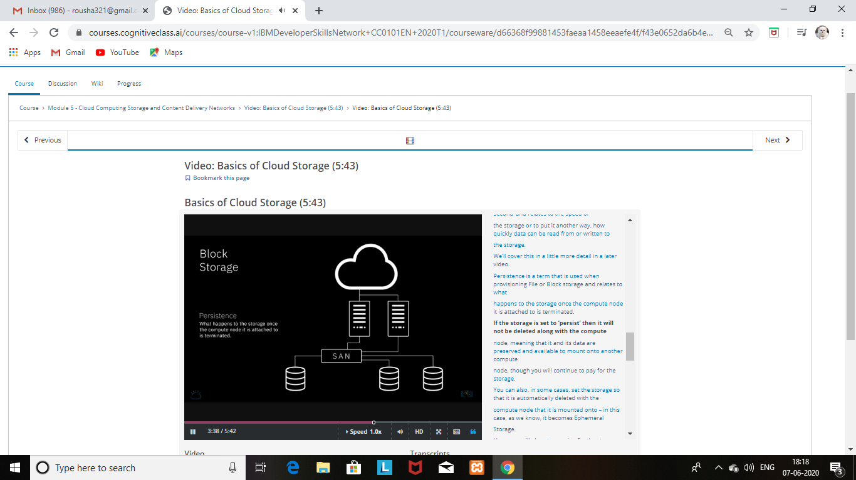

Shaifa:

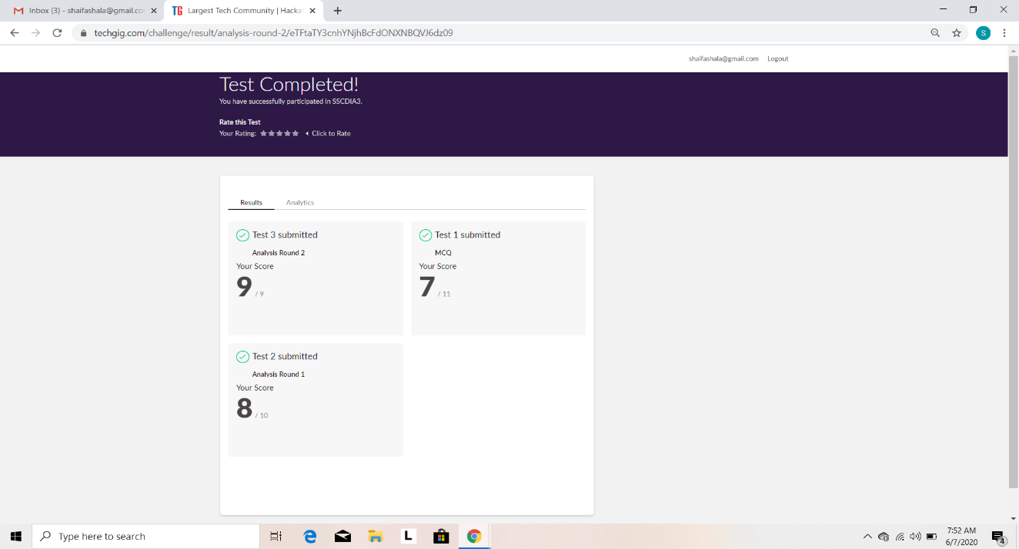

Certification Course Details: (Attach the snapshot and briefly write the report for the same)

